ASSIGNMENT-2

- pwd-Present Working Directory. shows the directory you are currently in when working in the shell.
$ pwd
/home/inchara/Downloads
- whoami-Who Am I. Shows the username of the currently logged-in user.
$ whoami
Inchara

- hostname-Host Name. Displays the name of the computer (host) on the network.
$ hostname
ubuntu-machine

- 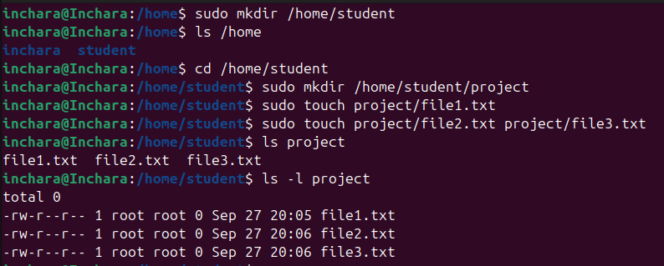
Feature | Absolute Path | Relative Path
definition  Starts with | absolute path gives the complete location of a file or directory starting from the root (/) directory.  / | relative path gives the location of a file or directory relative to your current working directory.  Does not start with /
Reference Point | Root directory (/) | Current working directory
Works from any location | Yes | No (depends on current location)
Example | /home/student/project | Project or ../project

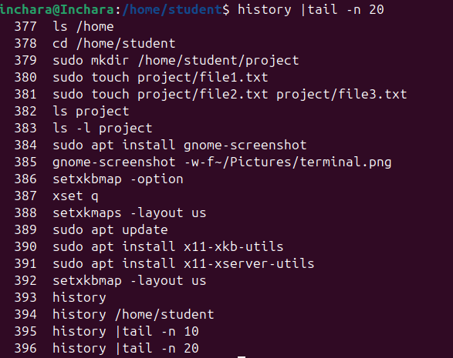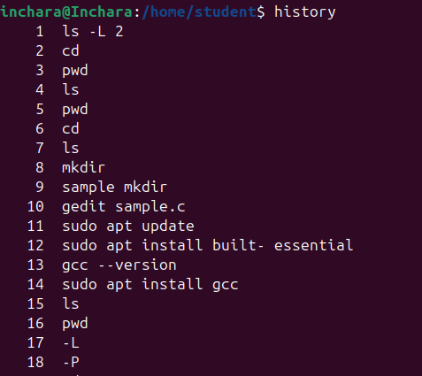
Only for present commands we use history |tail -n 20

- find-searches the filesystem in real-time by traversing directories from the path you give.
find /home/student -name "file1.txt"
• Pros:
- Always accurate and up to date.
- Very flexible (you can search by name, size, permissions, time, owner, etc.).
• Cons:
- Can be slow, especially on large directories, because it scans the file system each time.
locate-does not search the file system directly.
It uses a pre-built database (mlocate.db) of file names and locations, which is updated periodically (usually with updatedb).
locate file1.txt
• Pros:
- Very fast because it only queries a database instead of scanning directories in real time.
• Cons:
- Results may be outdated if the database has not been updated recently.
- Less flexible than find.
Feature | find | locate
Search method | Real-time filesystem traversal | Database lookup (mlocate.db)
Speed | Slower | Much faster
Accuracy | Always up-to-date | May be outdated
Flexibility | High (by name, size, time, etc.) | Low (mostly by name only)
Example | find /home -name "file.txt" | locate file.txt
locate is faster because it uses a database lookup instead of real-time scanning.
find is slower but always gives the most accurate and current results.

- The command used to modify file permissions in Linux is chmod (short for change mode).
chmod [permissions] filename
Permissions can be changed in two ways:
- Symbolic method (using r, w, x, +, -)
- Numeric/octal method (using 0–7 numbers)

Symbolic Method
chmod u+x script.sh
This gives the owner permission to execute the file
Numeric Method
chmod 754 file.txt
file.txt has permissions:
-rwxr-xr-- file.txt
- -rw-r--r—
It has 10 characters:
- First character (-) → Type of file
  - - = regular file
  - d = directory
  - l = symbolic link
Next 9 characters are grouped into 3 sets of 3:
- Owner (user) → rw-
- Group → r--
- Others (world) → r—
• It is a regular file.
• Owner can read and write.
- • Group and others can read only.

- chown-(Change Owner)
• Used to change the ownership of a file/directory.
• Ownership can be changed to another user (and optionally a group).
chown new_owner filename
or
chown new_owner:new_group filename
example-chown inchara file.txt
chgrp-Change group
• Used to change the group ownership of a file/directory.
• Only the group is changed (not the user).
chgrp new_group filename
example-chgrp developers file.txt

- File accessible (readable) by multiple users but writable only by the owner in Linux, you need to set the correct file permissions.
Using symbolic permissions:
chmod 644 filename
The file is
-rw-r--r-- filename
Owner can read/write
Others can only read
Using symbolic notation:
chmod u=rw,go=r filename
• u=rw → owner has read and write
• g=o=r → group and others have read only
- Can check the manual (man) page for any command using the man command
man command_name
example
man ls
This opens the manual page for the ls command, showing:
- Description of the command
- Options and flags
- Usage examples

. Searching within the manual page:
- Press /keyword → searches forward for keyword
- Press n → go to next match
- Press q → quit the man page
man -f command_name
Example:
man -f ls

Viewing a specific section:
Some commands have multiple sections (e.g., system calls vs user commands). Syntax:
man section_number command_name
Example:
man 2 open

